MINUTES of Special Meeting
Willington Housing Authority-Willington, CT
Tuesday, July 14, 2020 – 1 p.m.
Via a conference call in accordance with the Governor’s executive Order 7B (issued March 23, 2020)

Present (via conference call on (385) 799-9573): Chairman Don Berg, Treasurer Claudia D’Agata, Member William Bunnell. Attorneys J. Lawlor and J. Scaramozza attended only during the Executive Sessions portion of the meeting (conversing with the Board).

1. Call to Order – 1:08 p.m.

No members of the public were present (and none entered during the conference call).

2. Old Business – Senior Housing “Button Hill”

No old business was discussed at this time

3. Executive Sessions- per the Freedom of Information Act, Section 1-210) re. Management contract

C. D’Agata made the following motion: To have the Board move into Executive Sessions to discuss the Button Hill management contract proposals with legal counsel. W. Bunnell seconded the motion. The Board unanimously voted to discuss the Button Hill management contract proposals with legal counsel and entered Executive Sessions at 1:10 pm.

4. Executive Sessions (per the Freedom of Information Act, Section 1-210). Discuss Management Contract with legal counsel.

The Board had discussions with Attorneys J. Lawlor and J. Scaramozza

5. Return from Executive Sessions to special meeting

6. Return to special meeting

At 2:23 p.m. D. Berg made the following Motion: To close the discussions in Executive Sessions and returned to the special meeting, member W. Bunnell seconded it, no discussion, and vote was unanimous to close Executive Sessions.

7. Discuss any other business

After discussion with our attorneys in Executive Sessions, the Board decided D. Berg should contact persons involved with the relevant management proposals to request that they follow up with our legal counsel (about further discussions about the need to form an Affiliation relationship. D. Berg also noted that the costs to form such Affiliation-agreements may affect the cost of some management proposals.

8. Review and approval of 7/7/2020 minutes

The decision to approve the 7/7/2020 minutes was postponed to a future meeting.

Vote to Adjourn – The vote to adjourn the meeting was taken, it was unanimous and the meeting adjourned at 2:36 p.m.

Respectfully submitted by
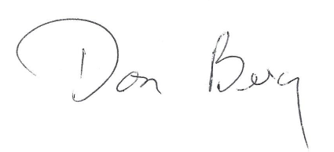
Chairman Don Berg
Please note that minutes are posted prior to being officially approved – changes/corrections are normally indicated in the subsequent month’s meeting minutes.

